**DevTools Task**

1. **Using Toogle Device Toolbar check the layout of this Twitter web-page** [**https://twitter.com/elonmusk**](https://twitter.com/elonmusk) **on mobile phones (emulate mobile phone).**

**Apple iPhone 4/4S 3 640×960**

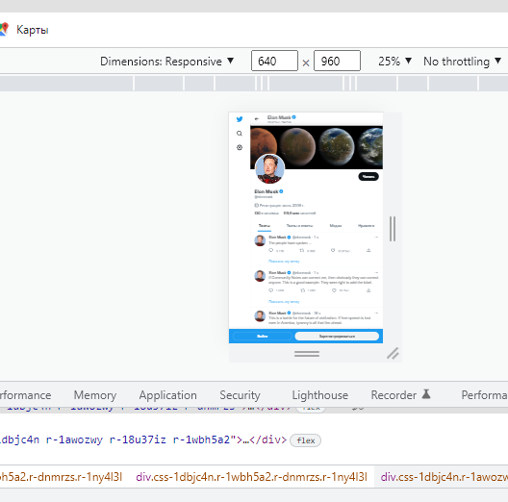

**Lenovo P70 5 1280×720**

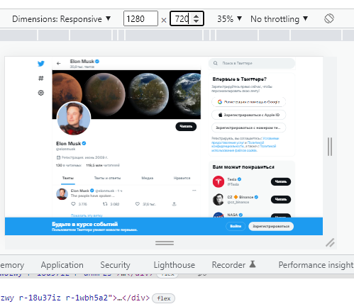

1. **Open https://www.joom.com/en.**

**Try to make 2-3 visible changes in style on the Main page.**

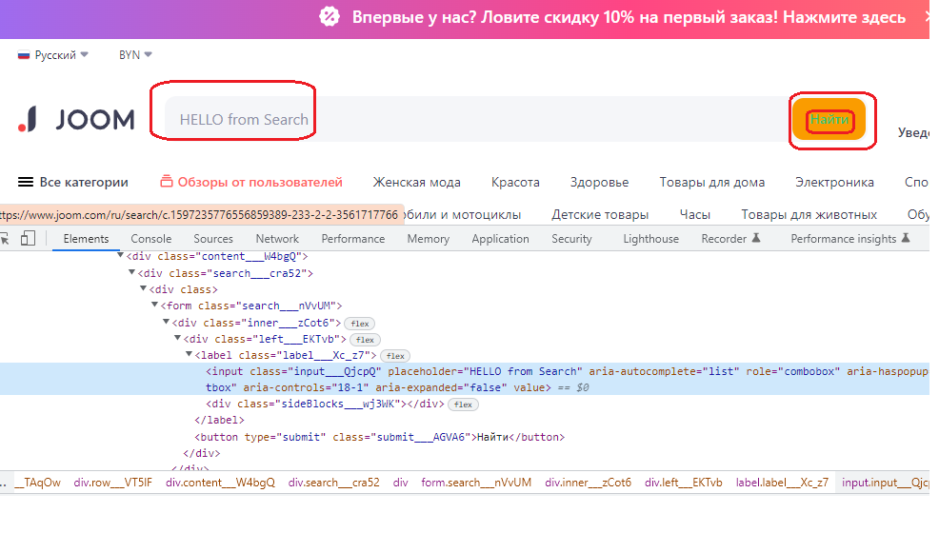

**3. Go to http://a.testaddressbook.com/.**

**Sign up to the site. Create new address and check HTTP Method used.**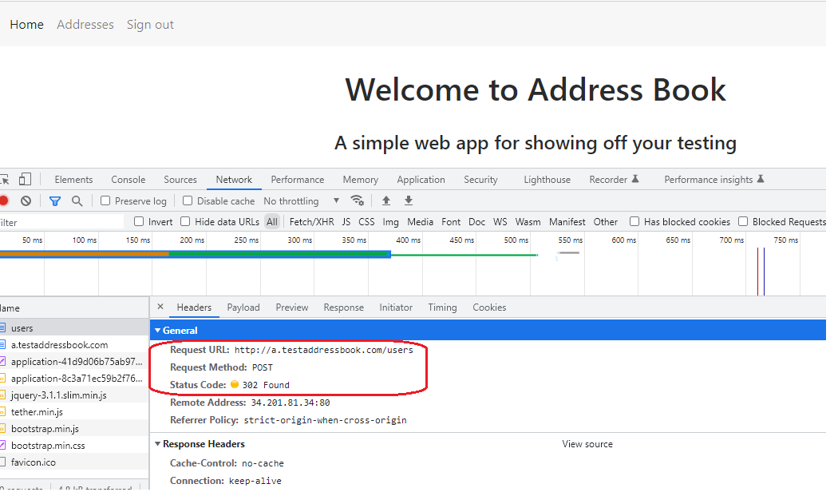

**4. Go to https://www.justit.co.uk/.**

**Find "About us" drop-down in the navigation bar on the Main page.**

**Using DevTools analyze how the code changes when you expand and collapse this drop-down.**

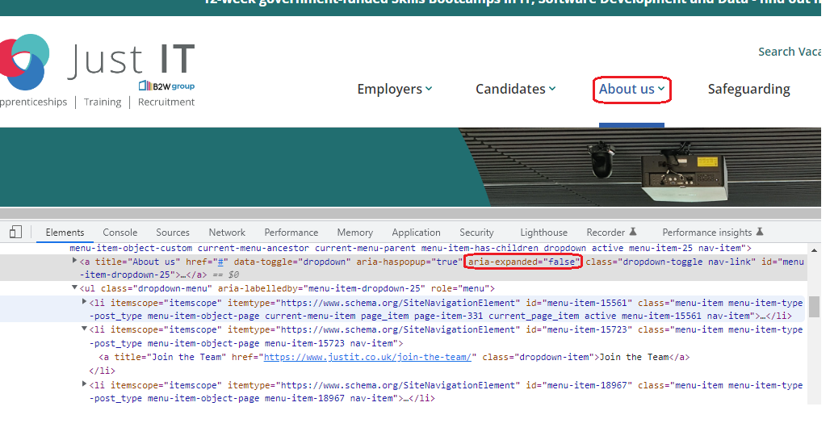

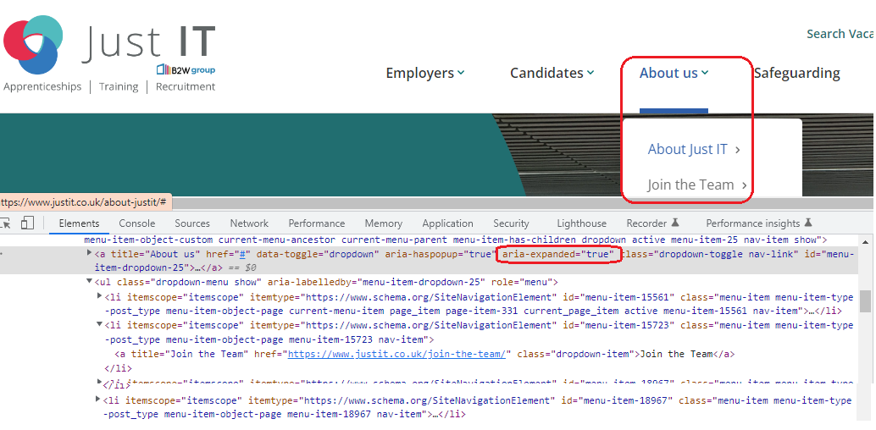

**5. Go to https://github.com/khsspider/portfolio.**

**Using DevTools identify errors.**

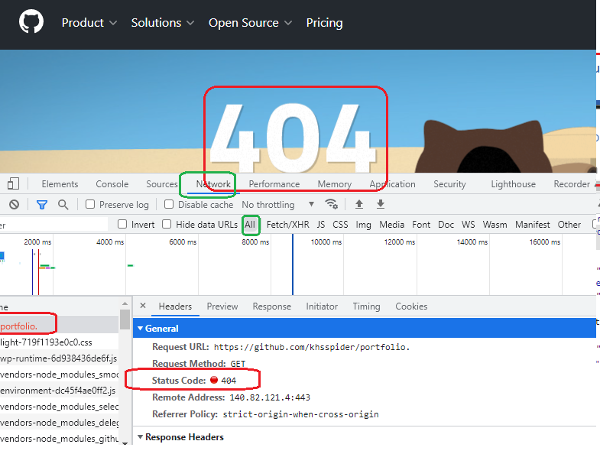

**6. Using the following command:**

**document.head.parentNode.removeChild(document.head);**

**remove JS and CSS from any web-page.**

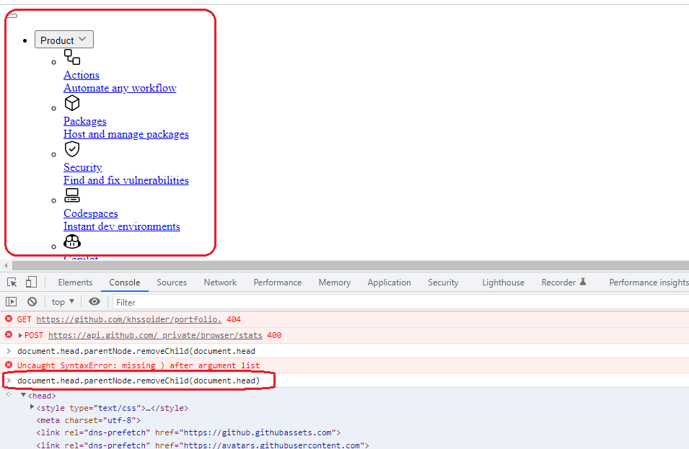

**7. Customize DevTools for you:**

**- change the place where it is shown (to the bottom or to the left)**

**- add additional columns into the table of the Network tab (add URL, methods, protocol and so on).**

